1.2 Volumes of Revolution: Washers & Disks & Solids Built from Bases

General Idea:
In this section we want to find a way to compute volumes of complicated solids using calculus. With this goal in mind we begin with a simple idea.

Notice we can estimate the volumes of three dimensional figures by adding up the volumes of “slices” or “slabs” of the figure. Some possible slices are pictured below.

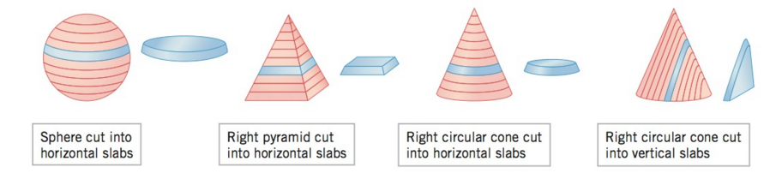

When we have more complicated solids, we will approximate the volume by using “cross sectional slabs” with uniform height and the same base shape on top and bottom. The next picture and definition make this idea precise.
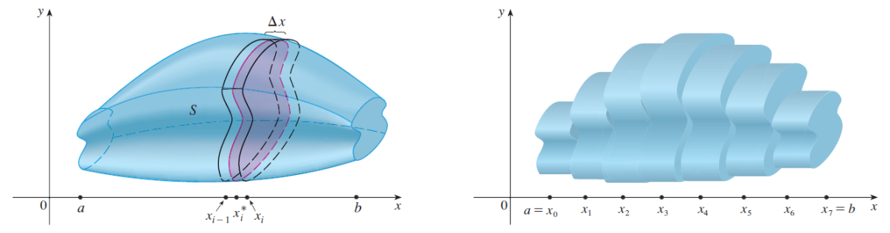
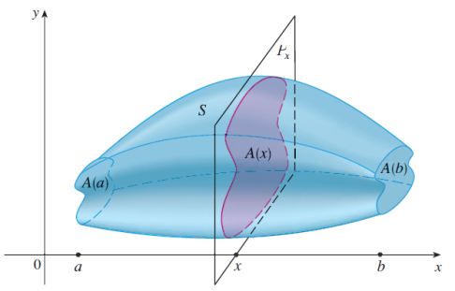

Definition: Let S be a solid that lies between . If the cross-sectional area of S in the plane , through x and perpendicular to the x-axis, is , where A is a continuous function, then the volume of S is

Note: If the solid is bounded by two numbers on the y axis, the definition becomes .
Our first application of this definition will be on solids of revolution. The idea behind solids of revolution is that we will rotate a region about the x or y axis and want to know the volume of the solid obtained.

Example 1: Consider the function

- Suppose we consider the region bounded by and the lines . | - Imagine that we revolve the area pictured to the left around the x-axis. Sketch a picture of the solid generated from performing this revolution.

- Imagine if we make vertical cuts into our 3-dimensional figure. What is the shape of the cross-sections?

Now we can use our definition of volume to find the volume for our 3-dimensional solid.
- Set up an integral to find the volume of the 3-dimensional solid pictured in part (b).

Note: From a Riemann sum point of view, we are really approximating the volume by using disks (i.e. right circular cylinders with very small height.)

Example 2: Find the volume of the solid obtained by rotating the region between the curves and from to about the line .

Example 3: Find the volume of the solid obtained by rotating the region bounded by (which lies to the right of) about the line .

Note: In all three examples we have seen, from a Riemann sum point of view we are approximating the volumes with disks. The general principle at play is stated below.

Disk Method

Volume of a Solid of Revolution (w/ a horizontal axis of rotation)
If S is a solid that lies between with circular cross-sections which are perpendicular to the x-axis, then the volume of S is given by
where r is a function of x which represents the radius of the circular cross-section at x.

Volume of a Solid of Revolution (w/ a vertical axis of rotation)
If S is a solid that lies between with circular cross-sections which are perpendicular to the y-axis, then the volume of S is given by
where r is a function of y which represents the radius of the circular cross-section at y.

Example 4: Find the volume of the solid obtained by rotating the region bounded by about the x-axis.

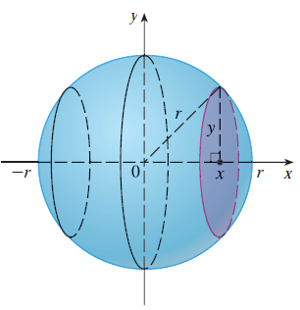
Example 5: Show that the volume of a sphere of radius r is .

Example 6: Find the volume when the region enclosed by the curves is rotated about the x-axis.

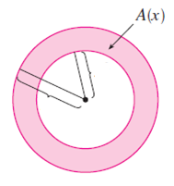
$$r$$
$$R$$

The general principle at play in this example is stated below.

Washer Method

Volume of a Solid of Revolution (w/ a horizontal axis of rotation)
If S is a solid that lies between with washer cross-sections which are perpendicular to the x-axis, then the volume of S is given by
where R is the outer radius, r is the inner radius and both R and r are functions of x.

Volume of a Solid of Revolution (w/ a vertical axis of rotation)
If S is a solid that lies between with washer cross-sections which are perpendicular to the y-axis, then the volume of S is given by
where R is the outer radius, r is the inner radius and both R and r are functions of y.

Example 7: Find the volume when the region enclosed by the curves is rotated about the line .

Note: This example shows us how important it is to always draw/measure our radius back to our original functions.

Example 8: Find the volume when the region enclosed by the curves is rotated about the line .

Solids Built From Bases

Example 9: Let the region formed by the function and the line form the base of a solid for which the cross-sections parallel to the x-axis are squares. Find the volume of the resulting figure.

